H.T No
Regulations:
A19

Sreenidhi Institute of Science and Technology
(An Autonomous Institution)
Code No:7P261 Date: 29-Oct-2021 (FN)

M.Tech I-Year II-Semester External Examination, Oct/Nov - 2021 (Regular & Supplementary)
ARTIFICIAL INTELLIGENCE & DEEP LEARNING (CSE and CS)

Time: 3 Hours Max.Marks:70

Note: a) No additional answer sheets will be provided.
b) All sub-parts of a question must be answered at one place only, otherwise it will not be valued.
c) Missing data can be assumed suitably.

ANSWER ANY 5 OUT OF 8 QUESTIONS. EACH QUESTION CARRIES 14 MARKS.

Bloom's Cognitive Levels of Learning (BCLL)

Remember | L1 | Apply | L3 | Evaluate | L5
Understand | L2 | Analyze | L4 | Create | L6

 |  |  | BCLL | CO(s) | Marks
1. | a) | What is the structure of Intelligent Agent? Discuss the various types of agent programs. | L2 | CO1 | [7M]
 | b) | Write short notes on classical planning problem. | L1 | CO1 | [7M]
2. | a) | In the graph below the start state is S, and the goal state is G. The transition costs are next to the edges, and the heuristic estimate, h, of the distance from the state to the goal is in the state's node. Assume ties are always broken by choosing the state which comes first alphabetically.  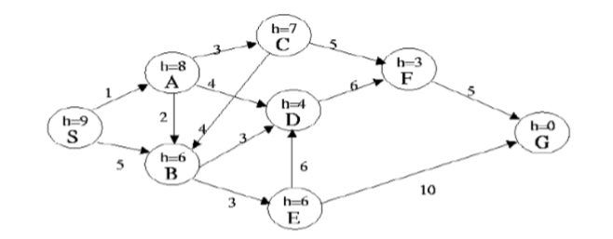  What is the order of states expanded using A* Search | L5 | CO2 | [7M]
 | b) | Write minmax algorithm which is used in game search. | L1 | CO2 | [7M]
3. | a) | Explain the predicate logic representation with a suitable example. | L2 | CO3 | [7M]
 | b) | Discuss issues in Knowledge representation. | L1 | CO3 | [7M]
4. | a) | In the following acyclic MDP calculate V(P) where C(a)=4, C(b)=9 C(c)=1  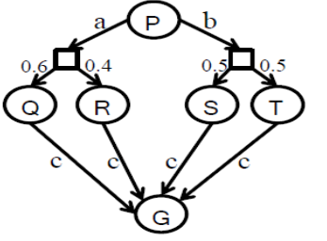 | L5 | CO4 | [7M]
 | b) | Differentiate between value iteration and policy iteration. | L4 | CO4 | [7M]
5. | a) | Write about shortcomings of feature selection. | L1 | CO5 | [7M]
 | b) | Draw and explain the architecture diagram of CNN. | L2 | CO5 | [7M]
6. | a) | Discuss real time applications of Markov Decision Process. | L2 | CO6 | [7M]
 | b) | Write about Deep Q-Networks. | L1 | CO6 | [7M]
7. | a) | Discuss types of environments. | L1 | CO1 | [5M]
 | b) | What are constraint satisfaction problems? | L2 | CO2 | [5M]
 | c) | Convert the formula (~A → B) ∧ (C ∧ ~A) into its equivalent CNF representation. | L3 | CO3 | [4M]
8. | a) | Explain how is reasoning done in situations with uncertain information? | L2 | CO4 | [5M]
 | b) | What is padding in CNN? | L2 | CO5 | [5M]
 | c) | What is reinforcement learning? | L1 | CO6 | [4M]

-- 00 -- 00 –

